Creating a Geological Map in ArcMap

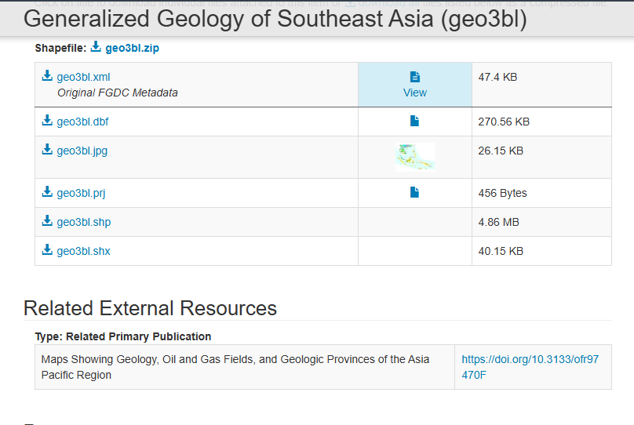

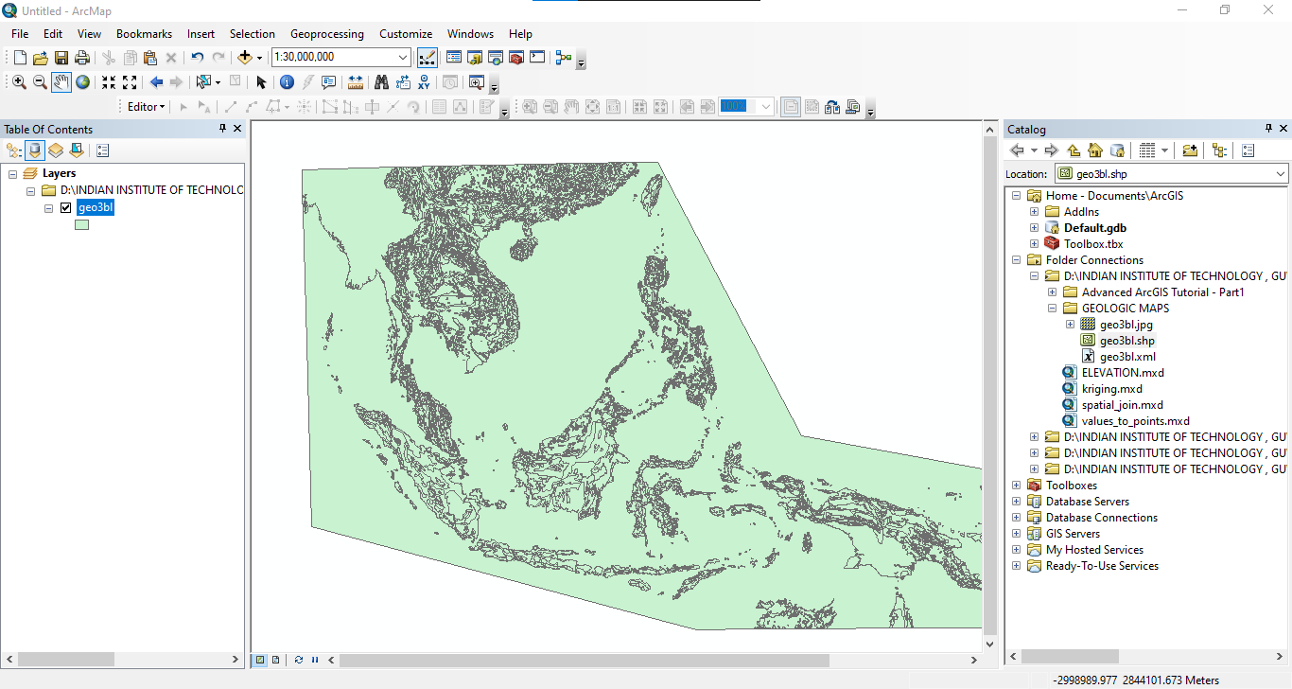

Check some metadata to understand what kind of a data set that we're dealing with

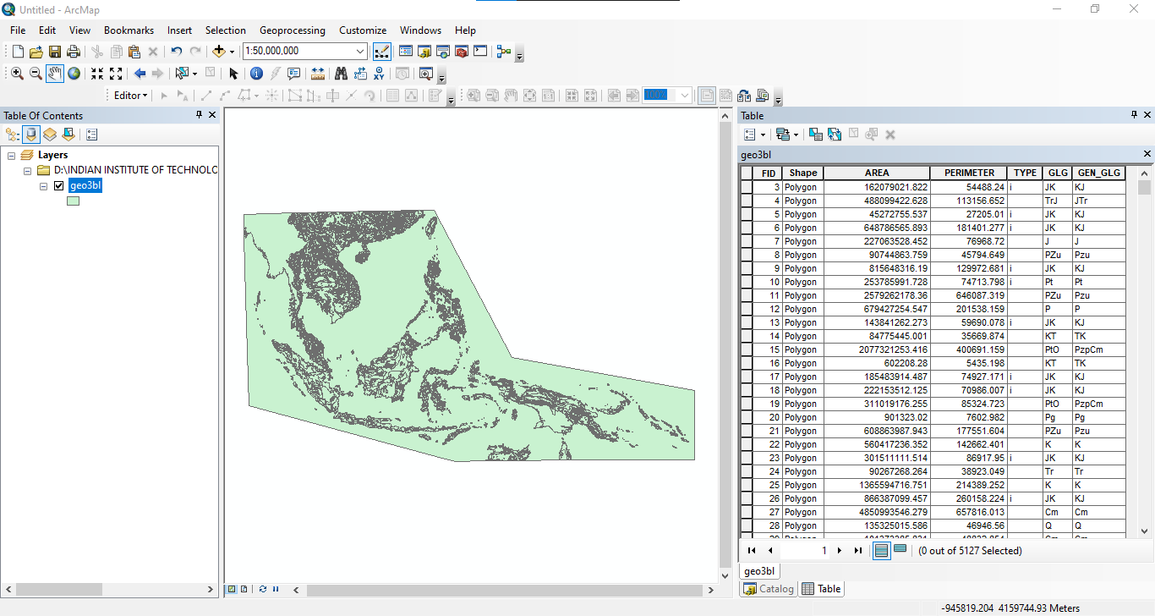

Different types of rock units that are belonging to different geological ages

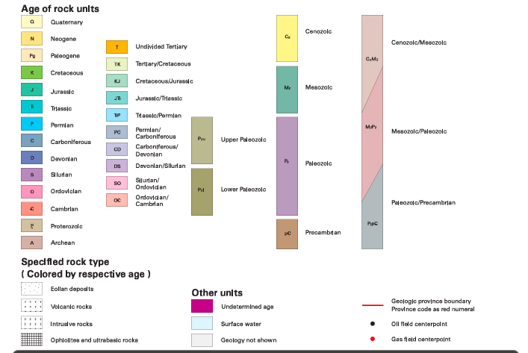

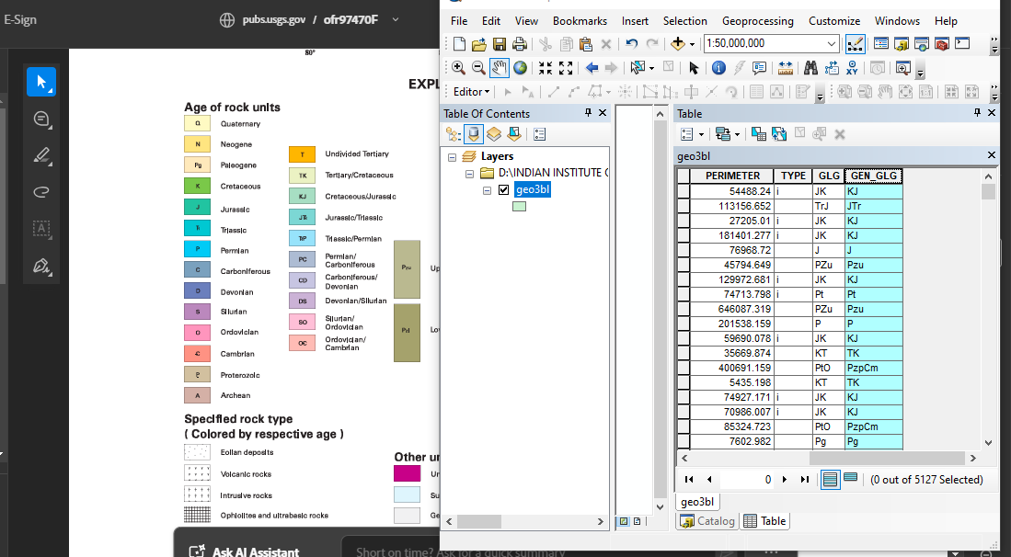

properties of this particular shapefile layer and check what sort of a coordinate reference system they're actually using so we can head over to this Source tab

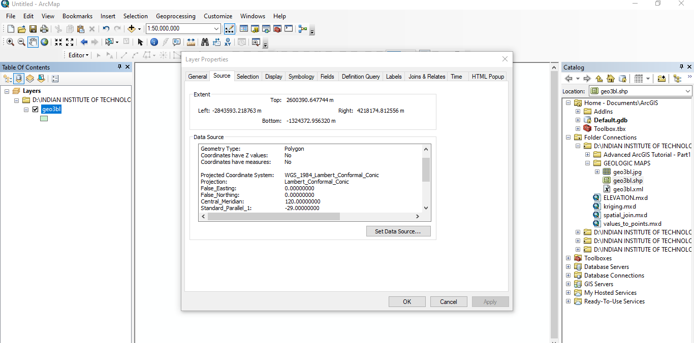

When using arcgis is that whenever you drag and drop a certain particular shape file layer the the coordinate reference system of the data frame automatically takes the coordinate reference system of the very first layer that you dragged and dropped now how can you be sure of that if you head to these layers and right click and go to properties if you head over to this coordinate system tab you will see that now the the coordinate reference system of the entire data frame has been changed to match the coordinate reference system of the shapefile that you dragged and dropped as the very first shapefile layer.

Objective would be to use an administrative boundary of a particular country and try to clip this data set

**Generalized Geology of Southeast Asia (**https://www.geoboundaries.org/countryDownloads.html)

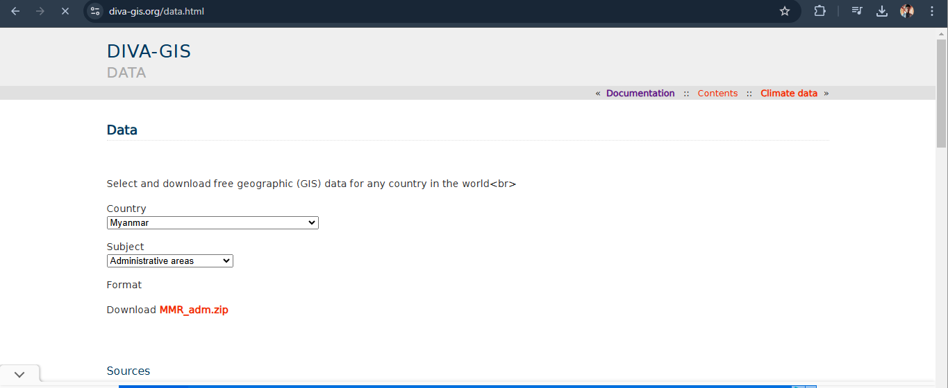

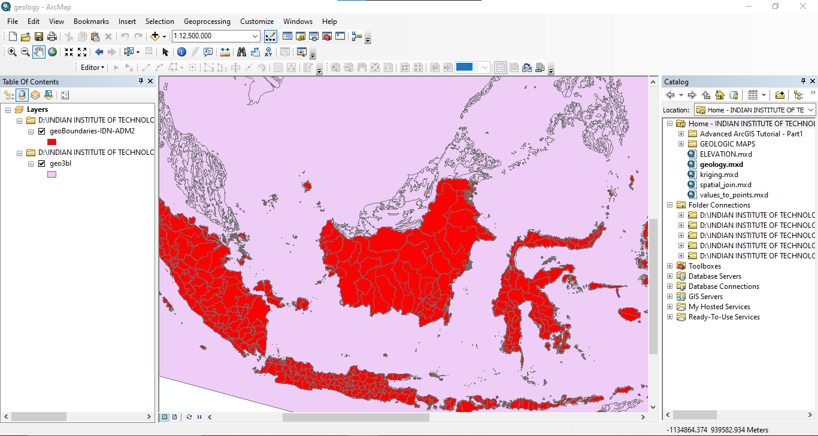

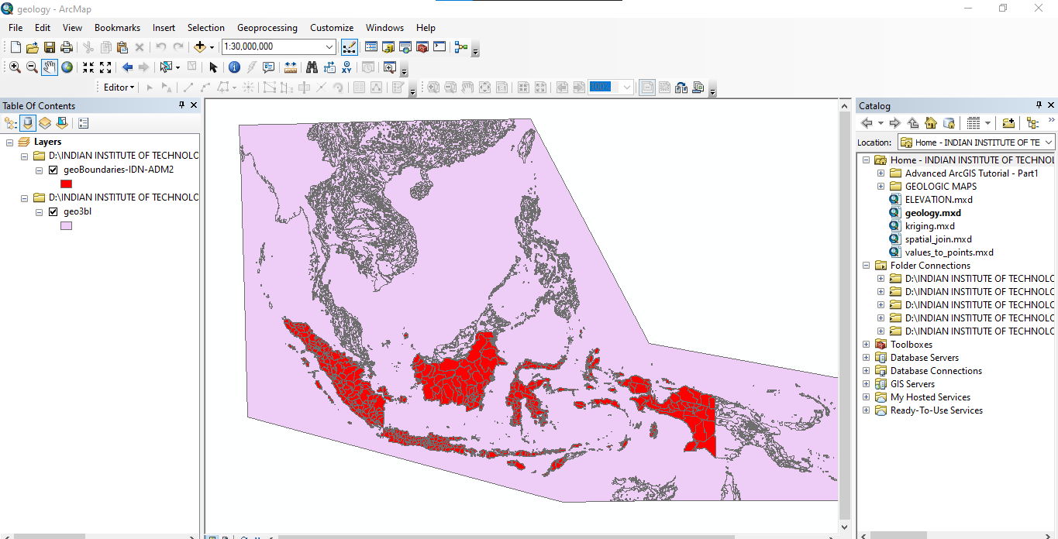

Wgs – 1984 , Geographic Coordinate System

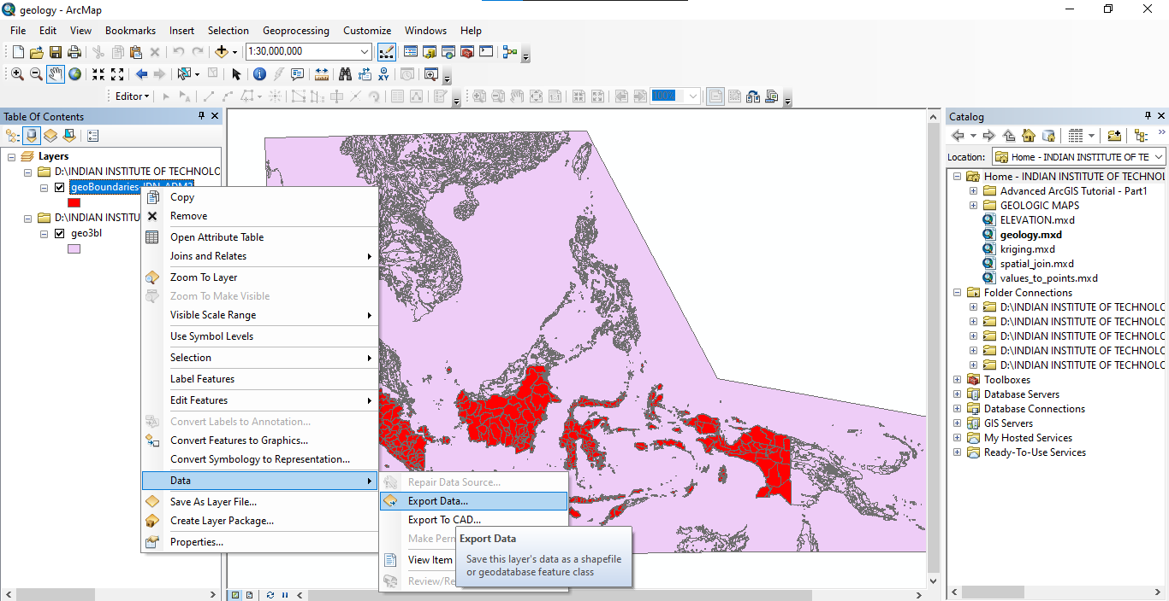

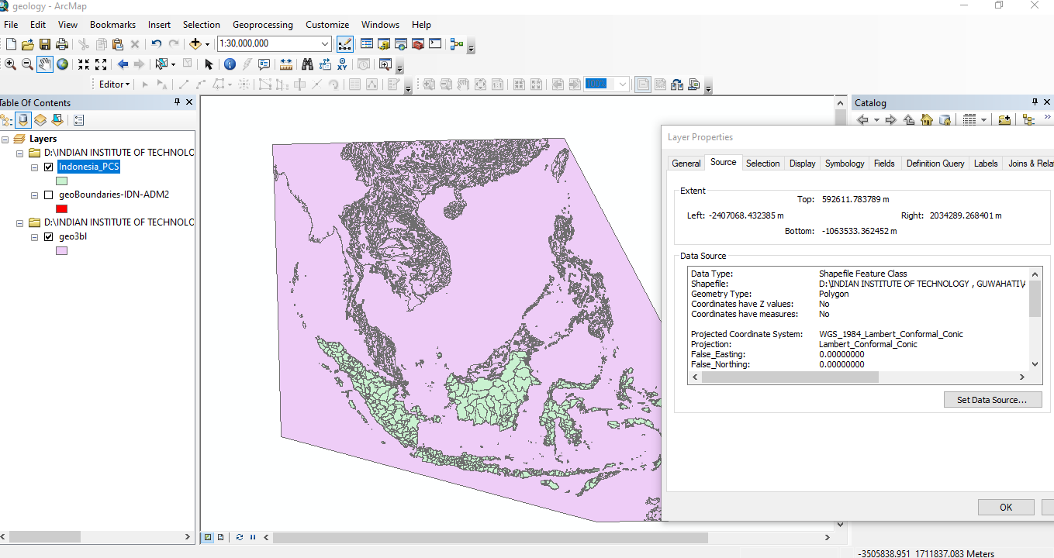

Intersect

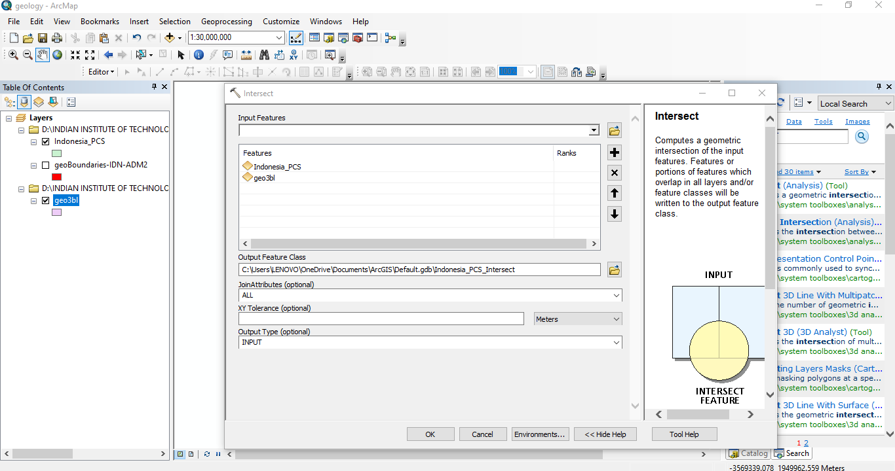

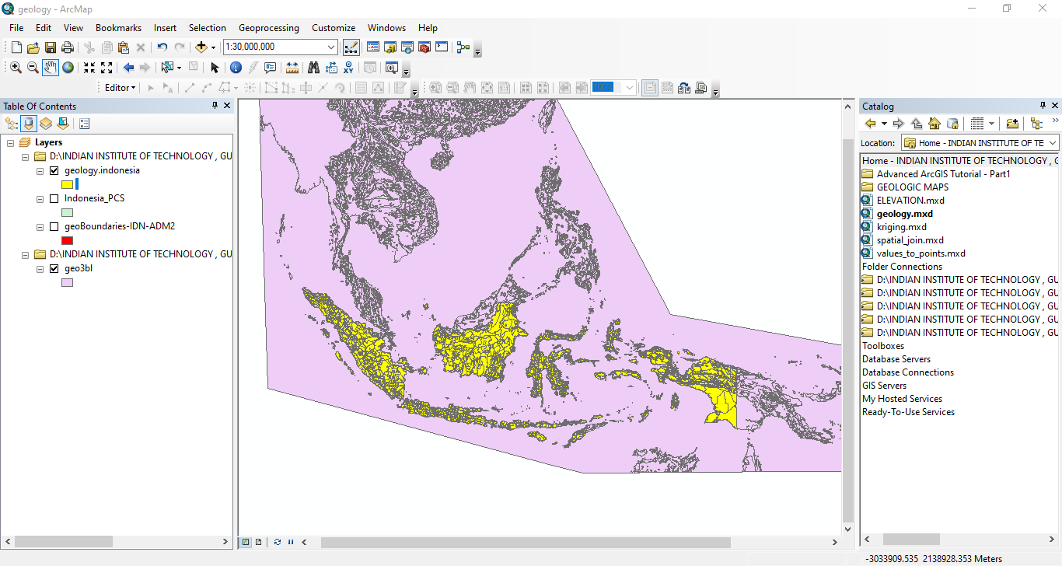

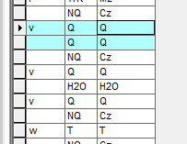

One more step just to make sure that we group all of these common geological uh notations as one single feature so that means we are going to actually group all these ends together.

Dissolve the Data

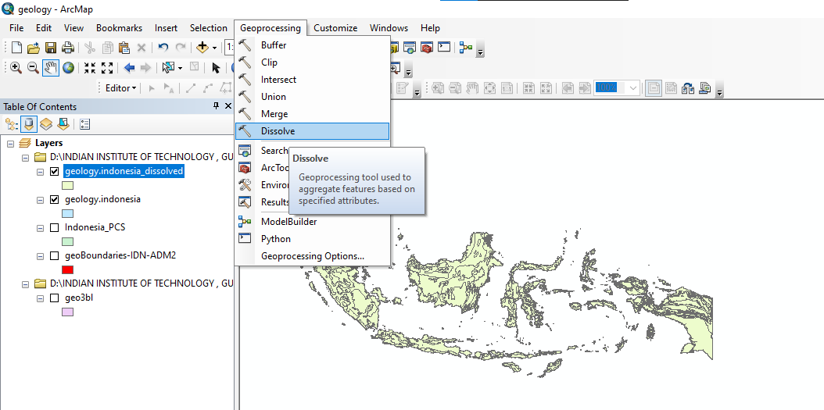

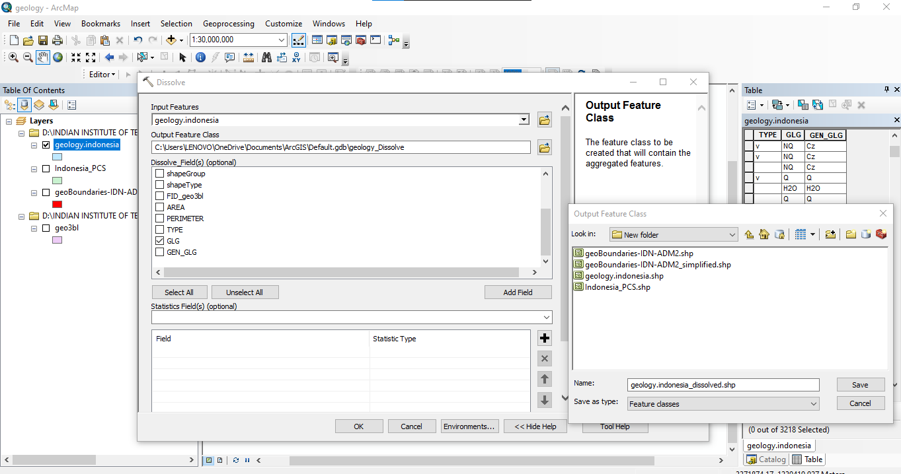

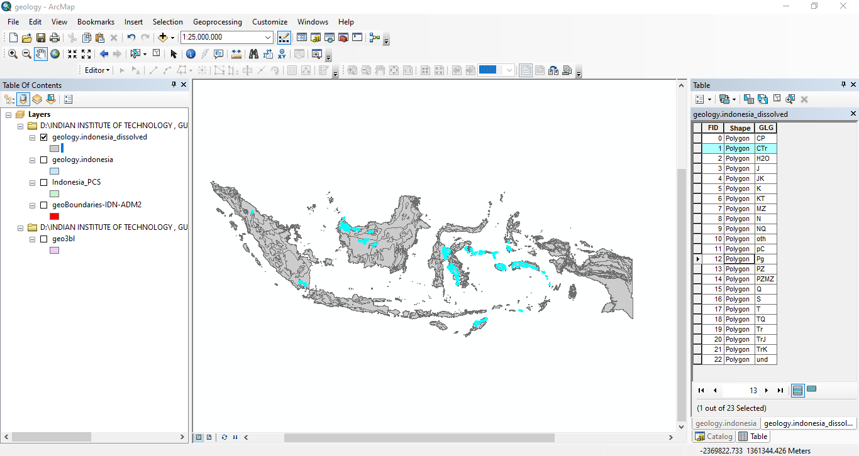

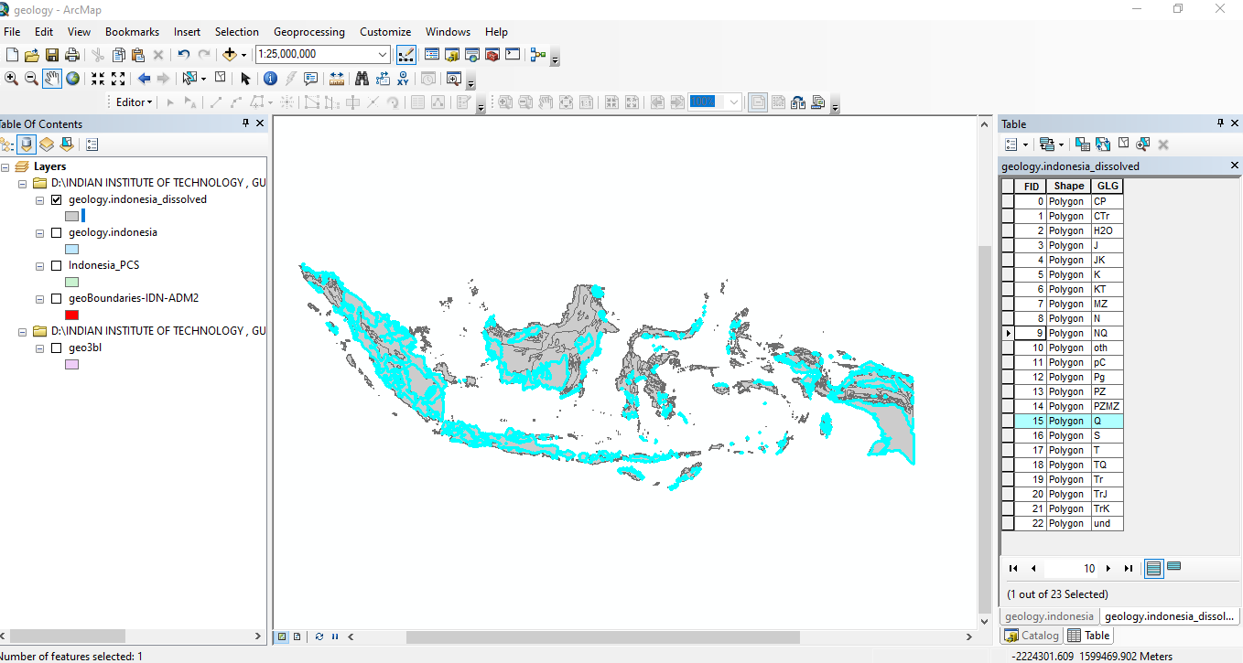

Most of the data preparation work is done

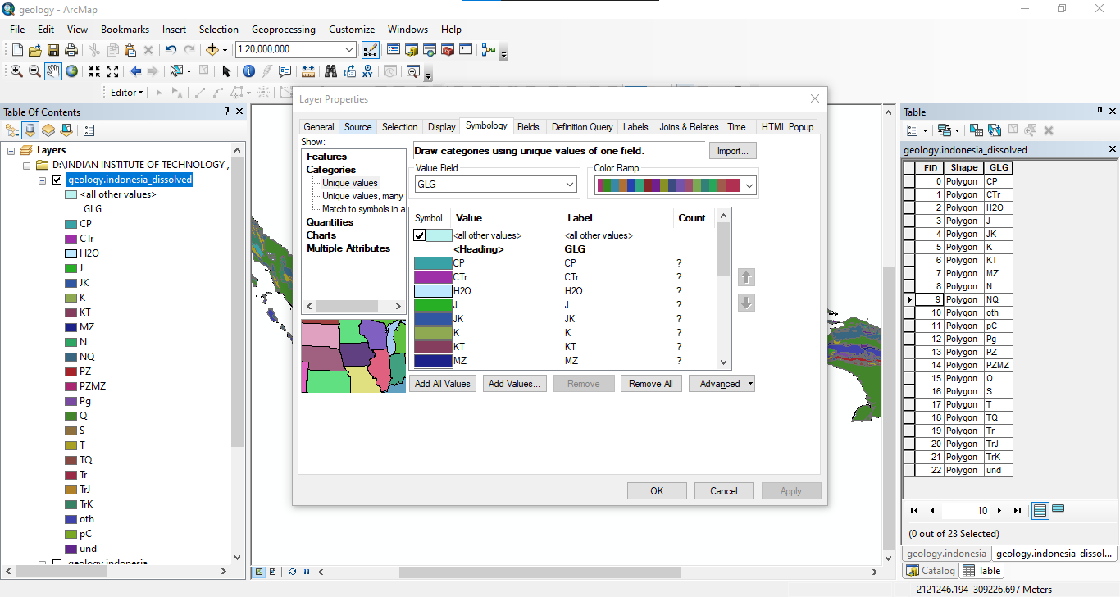

We have two buttons right next to each other the one that we are currently working on is this is called a data View and there's another one called layout view

Map that's presented within with a landscape view would be much better suited compared to a map that's presented with a portrait view well there are certain countries that would actually fit in quite nicely for with the portrait view for example country a country like Chile or Vietnam which kind of stretches vertically compared to a country like Indonesia which really has a spread to to West and East

So, to change the orientation what we can do is we can actually go to this layout panel.

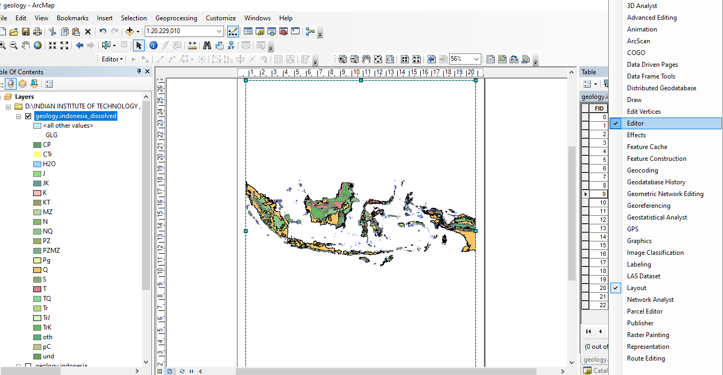

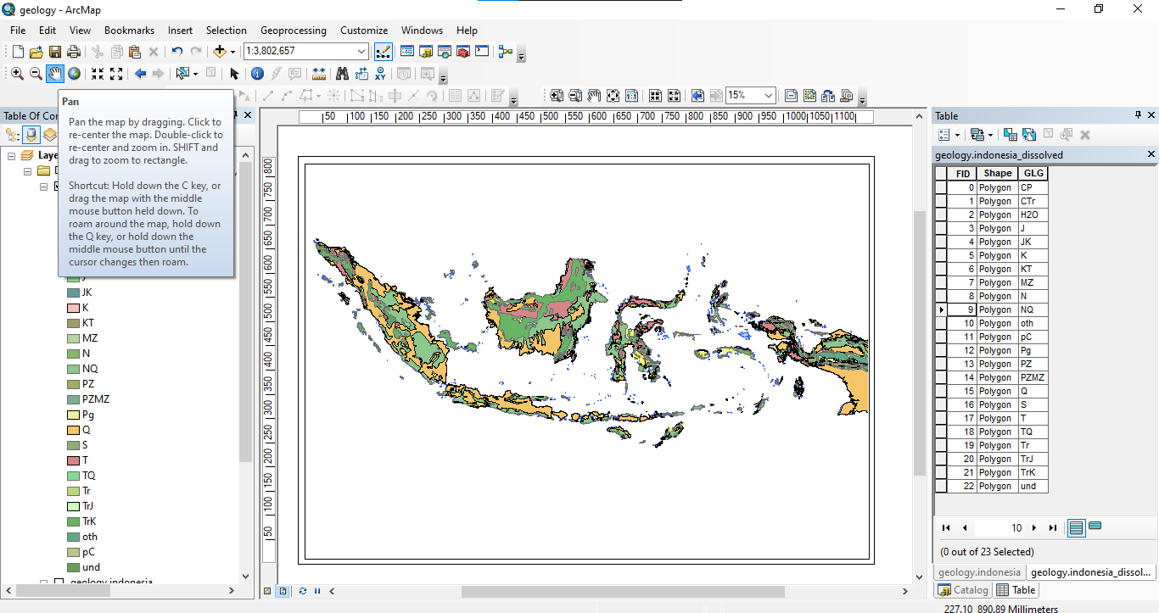

Import a legend

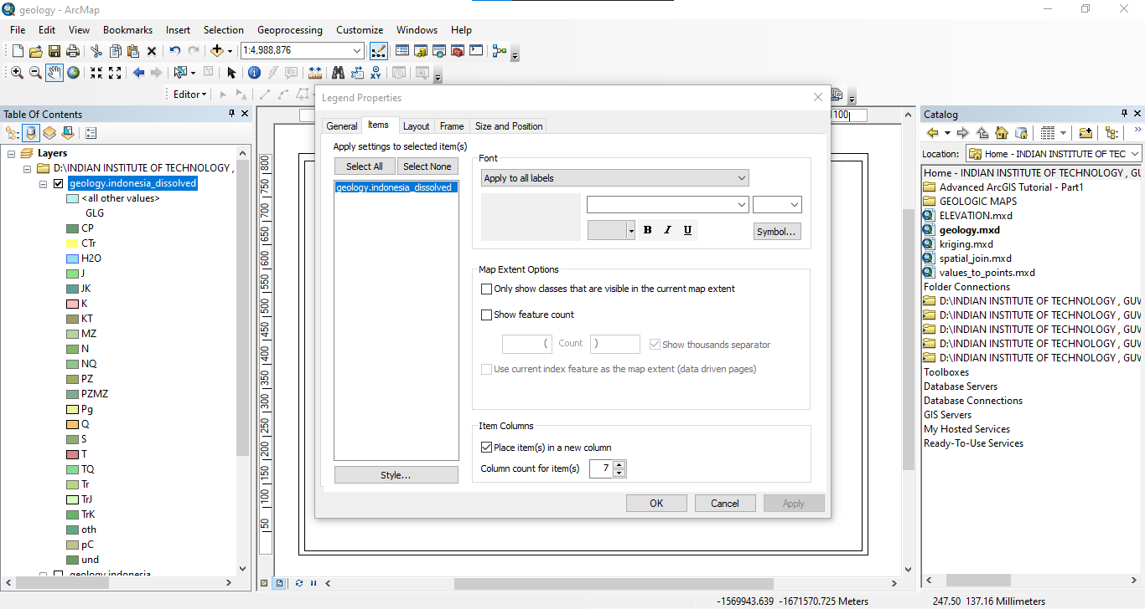

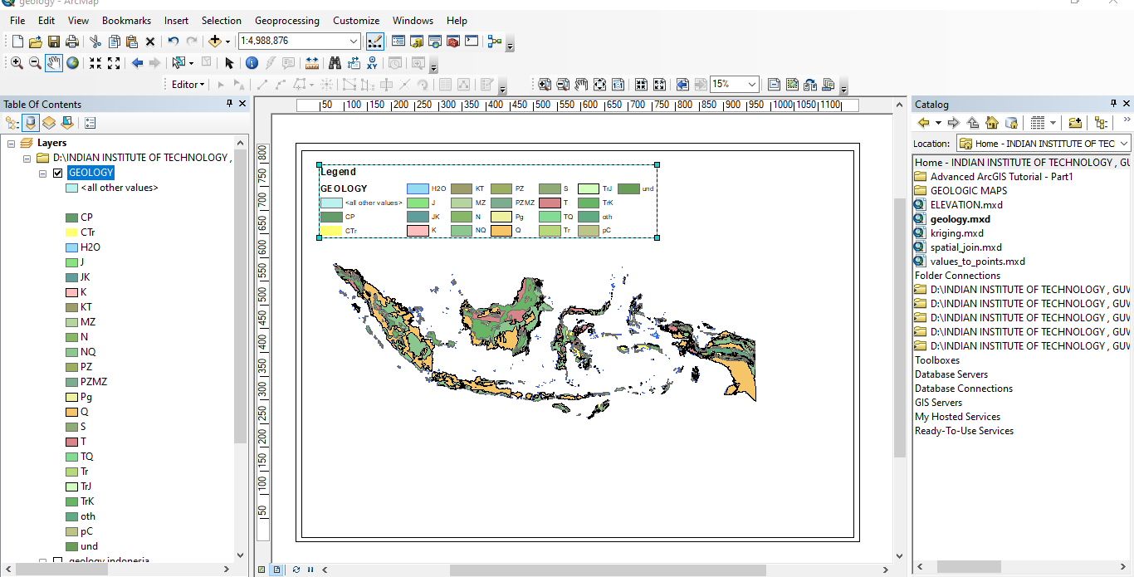

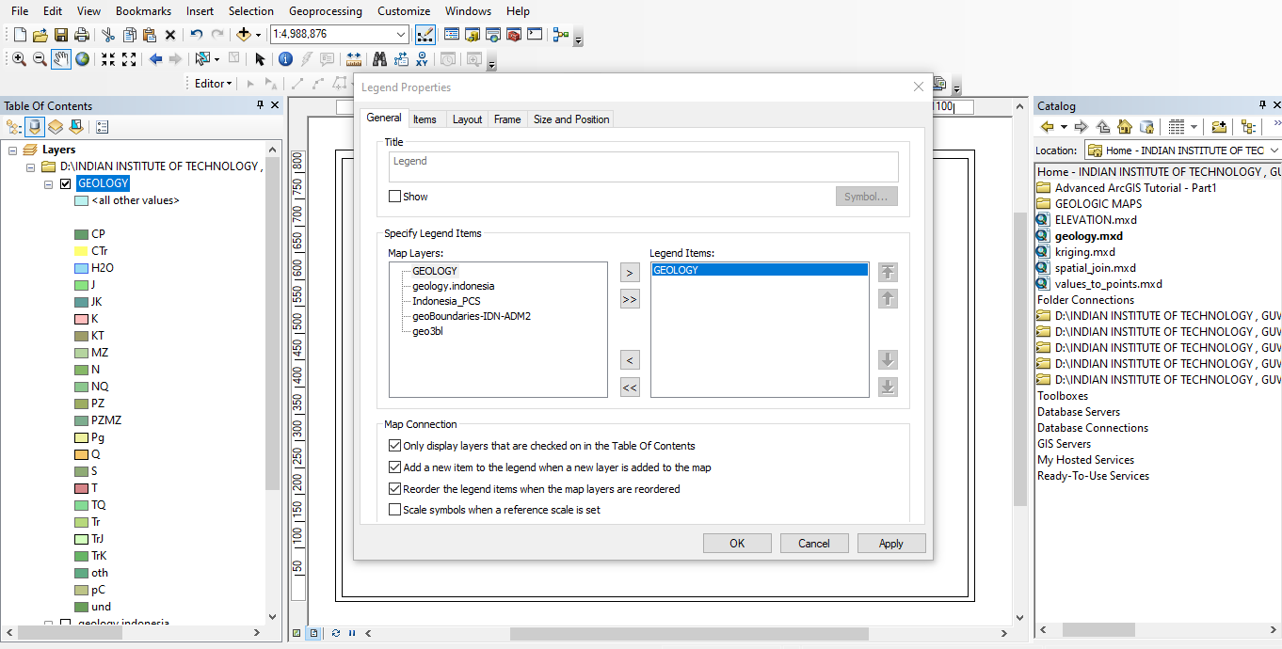

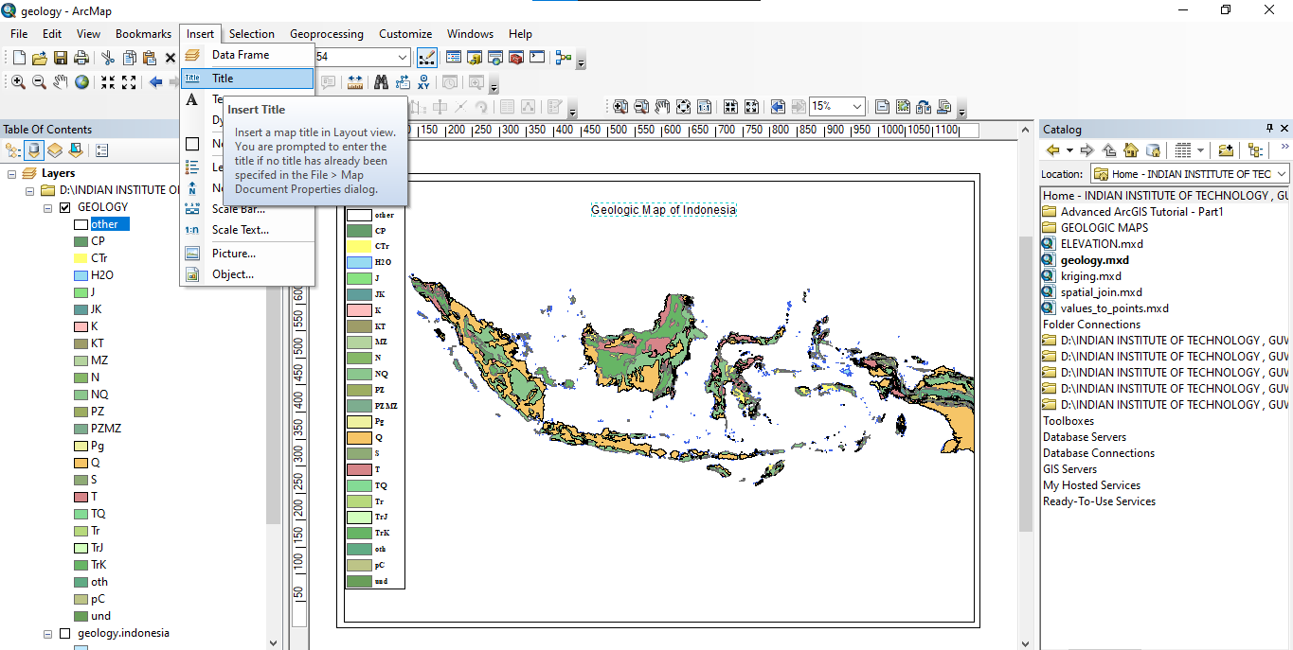

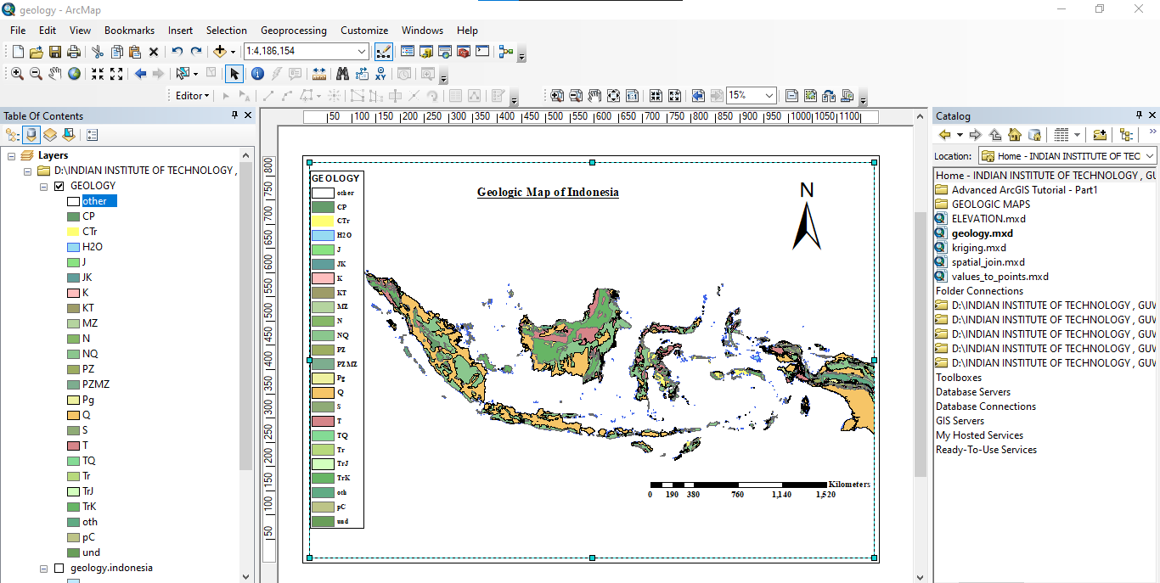

Add a base map to our map



